



PREDICTING CUSTOMER CHURN IN MUSIC STREAMING: A MACHINE LEARNING APPROACH USING KKBOX SUBSCRIBER DATA

Student Name: Omkar Pamidi
Dissertation submitted to International Business School for the partial
fulfilment of the requirement for the degree of MASTER OF SCIENCE IN IT FOR
BUSINESS DATA ANALYTICS
15 MAY 2026

DECLARATION

This dissertation is a product of my own work and is the result of nothing done in collaboration.
I consent to International Business School’s free use including/excluding online reproduction, including/excluding electronically, and including/excluding adaptation for teaching and education activities of any whole or part item of this dissertation.
Yours sincerely
Omkar Pamidi

(Signature)

Table of Contents
1
1
PREDICTING CUSTOMER CHURN IN MUSIC STREAMING: A MACHINE LEARNING APPROACH USING KKBOX SUBSCRIBER DATA 1
DECLARATION 2
EXECUTIVE SUMMARY 5
Design and Methodology 5
Solution 6
Limitations and Implications 6
Reflections 6
INTRODUCTION 7
Business and Technical Significance 7
Problem Statement and Objectives 8
Scope and Expected Contributions 8
LITERATURE REVIEW 9
Customer Churn: Definition and Business Significance 9
Machine Learning Approaches to Churn Prediction 10
Hyperparameter Optimisation and Class Imbalance 11
Temporal Data Leakage and Model Interpretability 12
Gaps in the Literature Addressed by this Study 13
METHODOLOGY 13
Data Sources and Collection 13
Addressing Temporal Data Leakage 14
Transaction Feature Engineering 15
Member Feature Engineering 16
Data Merging 17
Train, Validation, and Test Split 17
Imputation Strategy 18
Class Imbalance Handling 18
Evaluation Metrics and Model Selection Criteria 19
EXPLORATORY DATA ANALYSIS 20
Overview 20
Target Variable Distribution 21
Auto Renewal Behaviour 22
Cancellation Rate and Churn 23
Customer Tenure 24
Plan Duration Effects 25
Feature Correlation Structure 26
Summary of EDA findings & business implications 27
IMPLEMENTATION OF ALGORITHMS AND MODELS 28
Modelling Philosophy and Experimental Design 28
Model 1: Dummy Classifier (Stratified Baseline) 28
Model 2: Logistic Regression 29
Model 3: Random Forest 30
Model 4: XGBoost 30
Model 5: LightGBM with Optuna Hyperparameter Optimisation 31
SHAP Analysis 31
RESULTS AND ANALYSIS 32
Model comparison: Validation set 32
The Log Loss Advantage of LightGBM and Its Business Significance 33
ROC Curve Analysis 34
Overfitting Assessment 35
Confusion Matrix and Threshold Optimisation 35
SHAP Feature Importance Results 36
Explainability and Business Interpretability 36
BUSINESS INSIGHTS AND RECOMMENDATIONS 37
The Business Problem Restated 37
Model Output to Business Decision 38
Insights 38
Recommendations 40
ETHICAL CONSIDERATIONS AND DATA PRIVACY 40
CONCLUSION 41
Summary of Key Findings 41
Limitations 42
Future directions for research 42
References 43
Appendices 45
AI Disclosure 45

EXECUTIVE SUMMARY

In this Project, I evaluated a Machine Learning Pipeline for predicting customer churn on KK Box Customer churn dataset. KK Box is Popular music streaming platform across different parts of Asia. The main business problem is identifying customers who are at not able to renew their subscription before they leave. This helps the company use better and lower cost, customer retention strategies. The project uses supervised binary classification on historical transaction data and customer demographic information from around one million users.

Design and Methodology
I trained five machine learning models are trained with increasing complexity namely (a stratified dummy baseline, Logistic regression, Random forest Classifier, XGBoost and Optuna tuned LightGBM). Critical Methodical decision I made in this project are identifying and fixing temporal data leakage issue. This happened because some transaction data from the same period as the churn label was included in the training data, which made the model results unrealistically high with AUC scores above 0.97. After applying the cutoff date to 31 January 2017, the model results are close to Kaggle competition benchmarks. Features are created on 21.5 million transactions and customers demographic profiles. Important behavioural features included auto renewal rate, cancellation history, customer tenure, and recent payment activity.

Solution
XGBoost gave the best validation performance with a ROC-AUC score of 0.8791 and a PR-AUC score of 0.4824. LightGBM with Optuna tuned parameters produced much better probability calibration with a Log Loss of 0.2151. This was a 47% improvement compared to XGBoost’s Log Loss of 0.4021. Because of this, LightGBM is recommended for real business use where churn probability scores help decide how retention budgets should be used. SHAP analysis showed that auto-renewal rate, recency days, and cancel rate were the most important factors affecting churn prediction. Behavioural features were more important than demographic features overall.

Limitations and Implications
The transaction cutoff reduced the amount of available historical data, and the results are only related to KKBox users during the 2016 and 2017 period. Future work could use time series models and real-time prediction systems.

Reflections
This project showed the importance of strong methodology instead of only focusing on high prediction scores. Finding and correcting temporal data leakage, even though it reduced the model performance numbers, was the biggest learning experience. Working with 21.5 million transaction records also highlighted the importance of memory efficient data processing, modular coding, and systematic hyperparameter tuning in practical machine learning projects.

INTRODUCTION
KK Box is a music streaming service available in various Asian countries with more than 30 million songs and a substantial user base in every country. As a result, and with the rising competition, KK Box is at risk of losing customers who are simple to switch to various other sites with low cost and less long term contracts
In 2017, KK Box along with Kaggle and the Association of Artificial Intelligence released an anonymous data set consisting of transactions, customer information and labels of churn. This dataset was released as a Kaggle ML competition and was used to spur research on predicting customer churn.

Business and Technical Significance
The financial impact of customer churn is much bigger than only losing subscription income. Research shows that getting a new customer costs much more than keeping an existing customer. Depending on the industry, acquiring a new customer can cost five to twenty-five times more than customer retention (Reichheld and Sasser, 1990). For music streaming platforms, this creates a strong business reason to identify customers who may leave and use targeted retention strategies before they cancel their subscription. Even a model that correctly predicts a small number of churned users can help companies move marketing spending from expensive customer acquisition campaigns to more effective retention activities, improving overall return on investment.
From a technical view, churn prediction in music streaming platforms is more difficult than normal classification problems. One major challenge is class imbalance. In the KKBox dataset, only about 6.4% of users are labelled as churned. Because of this, normal accuracy scores are not very useful, and more advanced modelling and evaluation methods are needed.
Another challenge is the large amount of transaction data. The dataset contains 21.5 million payment records, so careful feature engineering is needed to convert customer behaviour into useful features for machine learning models. A very important issue is temporal data leakage. This happens when features are created using information from the same period as the churn label. In this case, models may show very high performance on historical data but fail when used in real business situations.

Problem Statement and Objectives
Designing a problem statement and objectives. Formulation of problem statement and objectives. The main research question for this project is whether a machine learning pipeline, based on behavioural and demographic features extracted from historical subscription data, can accurately predict customer churn in a music streaming environment, while using a scientifically sound methodology to handle temporal leakage, class imbalance and model interpretability issues? The project aims to:

Objective 1: Design a complete feature structure by combining transaction data with demographic data that best represents users' behaviour and financial attributes and use a hard temporal cutoff to prevent data leakage.
Objective 2: Train, compare, and evaluate 5 classification models from a stratified baseline to logistic regression, random forest, XGBoost, and Optuna-tuned LightGBM models to measure the performance of different models using ROC-AUC, PR-AUC, and Log Loss as evaluation metrics.
Objective 3: Run SHAP analysis on the top model to determine the most important factors which explain the prediction of churn and come up with business recommendations for churning strategy.
Objective 4: To develop a well-documented analytical pipeline that can be reproduced by others to verify the results and that can be extended in the future.

Scope and Expected Contributions
This project is based on the KKBox dataset released for the WSDM 2018 Kaggle competition. The study focuses only on binary churn prediction, which means predicting whether a customer will fail to renew their subscription within 30 days after membership expiry. The project does not cover other related problems like predicting when a customer will churn, will they return later or estimating customer life time value.
This work makes three contributions. First, it provides a clean and repeatable way to deal with temporal data leakage in churn prediction. This is an important problem that is frequently overlooked in many studies and can cause unrealistically high model performance results. Secondly, the project compares several machine learning models and measures the improvement of the model performance with the increase of model complexity. This is helpful to support the final model selection with clear evidence. Third, the project employs SHAP analysis to relate model predictions to real-world business actions. This helps to identify crucial customer behaviours related to churn and supports better strategies for music streaming customer retention.

LITERATURE REVIEW

Customer Churn: Definition and Business Significance
Customer churn is when a customer stops using a company's service. That is the challenge for subscription based businesses in the digital economy. According to (Reichheld and Sasser, 1990), increasing the customer retention rate by 5% will increase the company’s profit from 25% to 95%, depending on the industry. Therefore, many studies have been conducted to find customers who are likely to churn before they churn. This allows companies to be proactive about retention, rather than reactive once a customer leaves.
Churn is applicable to music streaming services where business revenue is based on monthly payments of subscription fees. Losing a customer means losing not only one payment but future income from that user. Churn prediction is an integral part of Customer Relationship Management (CRM) (Hadden et al., 2007). Predictive models can help companies target their retention efforts to the customers most likely to leave, thereby saving them on marketing expenses. The music streaming industry is also highly competitive, with low switching costs, making churn a significant issue. (Wlömert and Papies, 2016) examined this behaviour in music streaming services and showed how easy it is for users to switch between platforms.
Music services like KKBox, Spotify and Apple Music have similar music catalogues and pricing plans with few long-term contracts. This makes churn prediction a major competitive advantage. “Knowing who’s likely to churn early can help companies do something about that and improve customer retention.”
Platforms such as KKBox, Spotify, and Apple Music offer similar music catalogues and pricing plans, with very few long-term contracts. Because of this, predicting churn has become an important competitive advantage. Companies that can identify users who may cancel their subscriptions early can take action to improve customer retention.

Machine Learning Approaches to Churn Prediction
Research into churn prediction has changed significantly in the last two decades. Prior research is primarily based on statistical methods like logistic regression. Recent research applies advanced ensemble and gradient boosting models.
Logistic regression is still popular because it is simple, easy to understand and computationally efficient. It is still useful for churn prediction (Au et al., 2003), especially when businesses need interpretable results. However, logistic regression cannot easily capture complex non linear relationships between variables, which limits its prediction performance.
To solve this problem, researchers proposed decision tree ensemble methods. Random Forest (Breiman, 2001) is an ensemble of many decision trees to improve the prediction accuracy. It is robust to outliers and can automatically deal with irrelevant features. Random Forest has been shown to work well for telecom churn prediction, especially on high dimensional datasets (Idris et al., 2012). For this study, Random Forest is chosen as a compromise between simple linear models and sophisticated gradient boosting models.
Gradient boosting models are now among the best methods to predict churn on tabular data. XGBoost was proposed by (Chen and Guestrin, 2016) and became popular after winning several Kaggle competitions, including the original KKBox churn challenge. XGBoost builds decision trees in a sequential manner, so it can learn complex patterns in the data.
LightGBM developed by (Ke et al., 2017) improved this method by using a faster and more efficient tree building methods. It can achieve similar or better accuracy compared to XGBoost while training much faster. Therefore, it is applicable to large datasets like the 21.5 million transaction records used in this project.
More recent studies have applied deep learning methods such as recurrent neural network and transformer models for churn prediction (Martínez et al., 2020). These methods are good for sequential behaviour data but need high computational power and are less interpretable. They also tend to perform worse than gradient boosting models on structured tabular data. For this reason, they were not used in this project.

Hyperparameter Optimisation and Class Imbalance
The performance of gradient boosting models is highly dependent on the choice of hyperparameters such as learning rate, tree depth, regularisation and sampling ratios. These parameters are difficult to tune manually and take a lot of time. (Bergstra and Bengio, 2012) showed that random search is better than grid search when computational resources are limited. This process can be further improved by Bayesian optimisation methods, which can concentrate on the most promising parameter combinations.
(Akiba et al., 2019) introduced Optuna framework that employs Tree structured Parzen Estimator (TPE) to find better hyperparameter values. In this project, the LightGBM model is optimised with a total of 30 Optuna trials following best practices in modern machine learning.
Class imbalance is another major challenge of churn prediction. In the KKBox dataset, only around 6.4% of the users are labelled as churned. This means that a model that predicts “no churn” for all users could still achieve over 93% accuracy while giving no useful predictions. (Garcia , 2009) present some approaches to handle class imbalance such as oversampling, undersampling and cost sensitive learning.
This study employs cost sensitive learning using the parameter in XGBoost and LightGBM. This method adds more weight to the minority churn class without creating synthetic data such as SMOTE (Chawla et al., 2002), which can result in a higher risk of overfitting.
Choosing the right evaluation metrics is also important for imbalanced datasets. (Davis and Goadrich, 2006) showed that when the positive class is rare, PR-AUC is more informative than ROC-AUC. To fully evaluate ranking performance, precision-recall balance and probability calibration we report ROC-AUC, PR-AUC and Log Loss for this study.

Temporal Data Leakage and Model Interpretability
Temporal data leakage is a big problem in churn prediction studies. It occurs when features are created based on data at the same time as the churn label or data from the future. (Kaufman et al, 2012) showed that leakage can improve AUC scores by 10% to 20% and produce models that do not perform well in real world situations.
For example, in subscription churn prediction, leakage often occurs in the process of using transaction cancellation information during the prediction period as training features. This project tackles the problem by applying a strict transaction cutoff date before feature engineering . Leakage correction decreased AUC scores of the models from unrealistic values >0.97 to realistic values between 0.877 and 0.879.
The interpretability of models is also becoming increasingly important as companies want to understand why predictions are being made. SHAP (SHapley Additive exPlanations) was introduced by (Lundberg and Lee , 2017) to explain the impact of individual features on the prediction. SHAP offers both the direction and magnitude of feature effects for each prediction, unlike traditional feature importance metrics.
In this project we used SHAP analysis to interpret the final LightGBM model and to find the main features (behavioural and demographic) that are impacting the churn prediction. These findings are later used to back the business recommendations of the customer retention strategies.

Gaps in the Literature Addressed by this Study
Most of the churn prediction studies are focused on sectors such as telecommunication and banking, with a lesser focus on music streaming platforms. Music streaming datasets have unique features including very large transaction volumes, strong behavioural regularities in autorenewal and cancellation activities, and highly imbalanced churn labels.
Besides, several previous studies do not explicitly tackle temporal data leakage, and only few combine strong validation methods with SHAP based interpretability into one reproducible pipeline. This project intends to address these gaps by combining leakage safe feature engineering, systematic model comparison, automated hyperparameter tuning, and SHAP based business analysis into a single, reproducible machine learning framework using a large, real world streaming data.

METHODOLOGY

Data Sources and Collection
This data is collected from KK Box WSDM cup 2018 competition hosted by Kaggle. This data is too large nearing to 100 GB after unzipped so I accessed data from the Kaggle API in a collab environment. The raw files are stored in Google drive for permanent access during different sessions. This dataset contains 3 CSV files they are elaborated below.
First the (train.csv) file contains 992,929 unique user IDs (msno) and a binary churn label (is_churn). If this value is 1 then the customer failed to renew their membership within 30 days during February or March 2017. This file is used as a target label for model training and evaluation.
The (members_v3.csv) is the members demographics file containing city, age, bd, gender, (registered_via) and account registration date as columns. This file has data errors in age values including zeros, negative integers and some values exceeding 1000 which are later corrected before model integration.
The largest and most important data (transactions.csv) file containing 21 million payment records. Each row contains one subscription transaction and contains columns like (transaction_date), subscription expiry date, payment plan duration, list price and the actual amount paid. This also contains two binary features (is_auto_renew) which tells whether the auto renewal of subscription is enabled or not and (is_cancel) which tells whether the user manually cancelled the subscription.
Also, import from Kaggle is unlike traditional data loading methods because of the large structure of the data set. Instead of these methods Kaggle API is used to improve transparency. The original files are in the .7z file format later extracted automatically after download.
The datasets were loaded with a memory reduction function. This function reduced about 60% of memory by converting numeric columns to smaller data types possible without any precision loss. Integer columns are cast to int8, int16, or int32 as appropriate, and float columns are cast to float32. This step was important because the transactions dataset is 1.73 GB and Google Colab has a limited RAM. The function tests the min and max values of each numeric column and turns it into the lowest safe integer or float type without losing information.

Addressing Temporal Data Leakage
The most critical methodological choice of this project was how to address temporal data leakage in the transaction data. The churn label is based on whether customers renewed their subscriptions in February and March 2017. But the transactions dataset also contains records for the same time. When we use all transaction data, without cutoff date features like (is_cancel=1) and (is_auto_renew=0 )from January or February 2017 are part of the training data. The signals are not actually churn indicators, as they are tangible evidence of churn behaviour happening simultaneously.
This problem is called target leakage (Kaufman et al., 2012). This occurs when the data set of features inadvertently contains information about the variable we are trying to predict. As a result, models can perform very well on past data but fail when used in the real world.
In preliminary experiments without temporal cutoff, the models scored ROC-AUC above 0.97. This was much higher than the best Kaggle competition results of ~0.89, which clearly indicates that there was leakage.
To address this problem a strict cutoff date was employed before feature engineering: 31 January 2017. Only transaction records dated on or before this date were used. The transaction dataset was reduced from 21.5 million records to about 18.3 million records. After applying the cutoff, the model results were comparable to published benchmark scores. The best model had a ROC-AUC of 0.8791 on the validation dataset. This result is more reliable.

Transaction Feature Engineering
The raw transactions file contains different number to transactions for each user, which is unsuitable for direct model input. To solve this problem grouped aggregation was used to convert transactions history into one row per each user. Feature Engineering was performed for filtered transaction data for each transaction. A total of ten features were created to represent four areas of subscriber behaviour.
User engagement was measured using (trans_count), which shows the total number of transactions made by each user. This feature helps measure how actively the user uses the platform.
Customer behaviour related to subscription renewal was measured using (auto_renew_rate), which represents the percentage of transactions with autorenewal enabled, and (cancel_rate), which represents the percentage of transactions where the user manually cancelled the subscription. These two features became the strongest predictors of churn because they directly reflect customer decisions about continuing the subscription.
The financial profile of users was measured using (total_paid),( avg_paid), and (last_paid). These features represent the total amount spent, average payment amount, and most recent payment amount. They help show the user’s spending behaviour and whether spending is increasing or decreasing over time.
Subscription plan characteristics were measured using (avg_plan_days) and (last_plan_days), which represent the average and most recent subscription plan duration. Users with longer subscription plans generally showed lower churn rates during exploratory data analysis (EDA).
Temporal engagement was measured using (tenure_days), which calculates the number of days between the user’s first and last transaction before the cutoff date, and (recency_days), which measures the number of days since the user’s most recent transaction before the cutoff date. Recency is an important churn signal because users who have not made recent transactions are more likely to churn, even if they previously had a high auto-renewal rate.

Member Feature Engineering
Before creating features for this file needed to be cleaned as the age (bd) column contains unrealistic ages to remove that the age variable is limited to 1 to 100 years. A binary feature (member_age_fixing) was created to check whether the original age value was missing or invalid.
Another feature called (member_age_bin) is created by grouping ages into six categories based on decades. Gender was converted into numeric values 1 for male, 0 for female and -1 for missing and not specified ages.
Account age (member_reg_days) was calculated as the number of days between the account registration date and the cutoff date. This feature measures how long the user has been registered on the platform.
The city and registration method (registered_via) variables were kept as categorical features and used directly in the tree based models, since these models can work with ordinal integer values without additional encoding.

Data Merging
The three datasets were joined by user ID (msno)using left joins. This method kept all 992,929 users in the dataset of training labels, but some users may not have counterparts in the datasets of members or transactions.
Some users did not have transaction records before the cutoff date of 31 January 2017. This could happen because they had no earlier transaction history or because they joined the platform after the cutoff date. As a result, these users had missing values in all transaction features. These missing values were later handled using median imputation.
After merging the datasets, the final feature matrix was saved to Google Drive in Parquet file format. Parquet files load much faster than CSV files and also use less storage. Another important advantage is that Parquet file preserves data types between sessions. Because of this, future Google Colab sessions could load the prepared dataset directly without repeating the full data loading and feature engineering process, which normally takes time on the raw files.

Train, Validation, and Test Split
For the final feature dataset is split using stratified random sampling. This kept the churn rate 6.4% similar across all the three sets. A 70, 15, 15 split is used to create training set of 6,94,000 users and 1,49,000 users for both test and validation split.
A three way split is used instead of two way split of 80/20 because using the test set for hyperparameter tuning can cause over fitting to test data. Therefore, makes the test results unreliable for model performance.
The validation dataset was used for all model tuning and optimisation tasks, including the 30 trial Optuna hyperparameter search. The test dataset was kept separate and used only for final model evaluation after all modelling decisions were completed. A random state value of 42 was used throughout the project to ensure reproducibility.

Imputation Strategy
Missing values in all numeric features were handled using median imputation. The median values were calculated only from the training dataset and then applied to the validation and test datasets. This method prevents information from the validation or test sets from affecting the preprocessing stage, avoiding a type of data leakage that is often ignored in practical studies.
Median imputation is used instead of mean imputation because several variables, such as (total_paid), (tenure_days) were highly skewed by a small number of high value users. So, the mean of this distribution is pulled upward by number of outliers. At the same time the median distribution is robust to central values and gives more of central estimates for imputation.
Most importantly these median values are only calculated from the training data set and applied directly to test and validation datasets. This is done to prevent any preprocessing data leakage and information from unseen datasets doesn’t affect anything.
After imputation, checks were performed to confirm that there are no missing values in any dataset before model training started.

Class Imbalance Handling
Instead of using data level resampling methods such as SMOTE, this study handled class imbalance using algorithm level cost sensitive weighting. SMOTE creates synthetic data samples, which can increase the risk of overfitting (He and Garcia, 2009).
The dataset has churn rate of only 6.43% which in turn creating class imbalance ratio of 14.4: 1. Without correction, most ML models would learn to predict “no churn” because that minimizes training loss. This will predict high accuracy but no real business value because no at risk customers are found.
Initially SMOTE over sampling method is also employed to create synthetic data samples but it is introducing unrealistic patterns and overfitting. So, algorithm level is employed instead of SMOTE.
In XGBoost and LightGBM models (scale_pos_weight) is set to the ratio of non churn users to the churn users which is 14.4. This makes model gives more importance to churn users than non churn users.
In Random Forest, (class_weight = 'balanced_subsample’) was used as this method automatically adjust class weights based on class distribution.
This method improved minority class detection without modifying the dataset by any unrealistic patterns.

Evaluation Metrics and Model Selection Criteria
Churn prediction is an imbalanced binary classification problem. The reason its imbalanced is because the number of Churn users is very small compared to number of retained users. In this data set as we already discussed only 6.43 % of users are only churned. Under such conditions traditional classification models predicts every user as non churned and gives us an accuracy over 90 percent but provides no business value. For this reason we took ROC-AUC, PR-AUC and log loss as metrics than considering accuracy alone.
The Receiver Operating Characteristic Area Under the Curve (ROC-AUC) indicates how well the model can separate the churned and retained users at all classification thresholds. A score of 0.5 is considered random guessing and a score of one is perfect separation. One of the great things about ROC-AUC is that it ranks the measure of the quality of the ranking without making any assumptions about a fixed threshold. For commercial churn prediction, it's common for the firm to be more interested in which users are relatively at greater risk than others, rather than perfect binary predictions.
But the ROC-AUC is overly optimistic on very imbalanced datasets, giving the same weight to true positives as true negatives. The fact that most of the users belong to the non churners makes it possible to get a high ROC-AUC for a model that fails to detect churners well. Thus, the PR-AUC was used as well. PR-AUC is specifically oriented towards the minority positive class and measures the precision recall curve.
Recall refers to the percentage of churners who were correctly predicted and Precision to the percentage of churners who were correctly predicted. Precision and recall are straightforward monetary issues in retention campaigns. Low precision leads to wasted marketing money that is too many loyal users are being pursued when they don't need it, and low recall results in the loss of actual users of at risk users to churn, as they do not receive any marketing.
The third evaluation metric was Log Loss which is the metric that would be important for this project in the long run as it wants to rank users as well as provide accurate estimates of churn probabilities for business decision making. Log Loss penalises models that make overconfident incorrect predictions. A smaller Log Loss means that people are pretty accurate in their predictions and those predictions are close to observed probabilities.
The model based on the production retention system should be able not only to display high risk users, but also estimate the risk of user churning, allowing budgets to be allocated to users in proportion to their risk. For instance, if a user is estimated to have an 80 percent chance of churning, the offer might be greater than a user estimated to have a 35 percent chance of churning.
So, probability calibration is necessary for financial optimisation. ROC-AUC, PR-AUC, and Log Loss are complementary to each other and are more complete than any single measure. ROC-AUC is a measure of ranking ability, PR-AUC is a measure of the quality of minority class detection, and Log Loss is a measure of probability calibration. These metrics, taken together, make sure that the model is not only a good fit statistically, but also useful for a business.

EXPLORATORY DATA ANALYSIS

Overview
Exploratory Data Analysis (EDA) is done before model training to know the structure of data, to validate the engineered features and to identify the important patterns that would be useful to train the model. A total of six visualizations are made to study class distribution, customer behaviour, temporal trends and feature correlations. Key numerical findings are noted.

Target Variable Distribution
The training set contains 992,929 users of which 63,905 are churned users (6.43%). This high class imbalance is present in model selection and evaluation. The accuracy of this simple model, which predicts a no churn for each user, is 93.57%. This indicates that accuracy is not a good metric to use to evaluate this problem. As a result of this, the project primarily focuses on ROC-AUC and PR-AUC which are better suited for imbalanced datasets.
Dummy Classifier model is a model that makes predictions based on the class distribution only without using any features. It has an ROC-AUC of 0.4981 and was employed as a benchmark for performance.
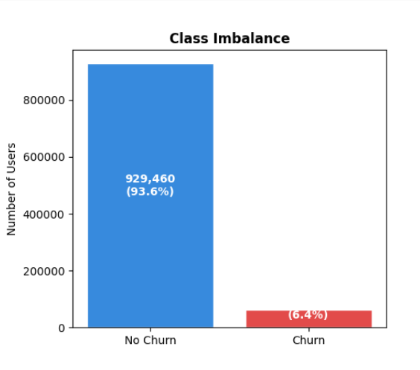

Auto Renewal Behaviour
Auto Renewal is the most Important feature of this project. Users with an (auto_renew_rate) below 0.5 had churn rates about eight times higher than users with high auto renewal usage more than 0.5.
This result matches customer behaviour theory because enabling auto renewal shows commitment to continuing the subscription, while disabling it may indicate that the user is considering cancellation.
The strong relationship between auto renewal and churn made (auto_renew_rate) the most important feature in the prediction models and a key target for customer retention strategies.
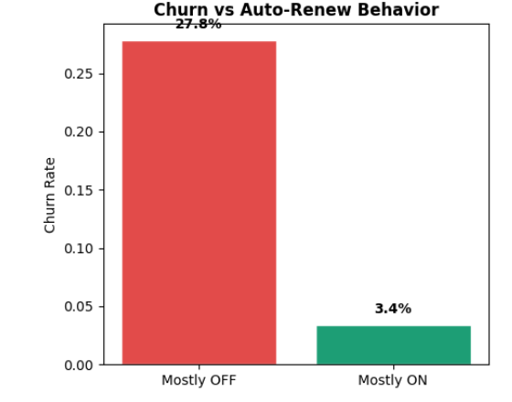

Cancellation Rate and Churn

There was a strong positive correlation between the cancellation rate and the churn probability. The (cancel_rate) of users with a value greater than 0.5 was significantly higher than medium (cancel_rate) value of average users.
(cancel_rate) and (auto_renew_rate) are related but not exact opposites. For example, some users may mostly use auto renewal but still cancel subscriptions occasionally. This creates different churn behaviour patterns.
The average correlation between these features is moderate, indicating that they both contain useful information and are independent. The most important features in the Logistic Regression model were (auto_renew_rate) rated top and the (cancel_rate)rated fifth respectively.
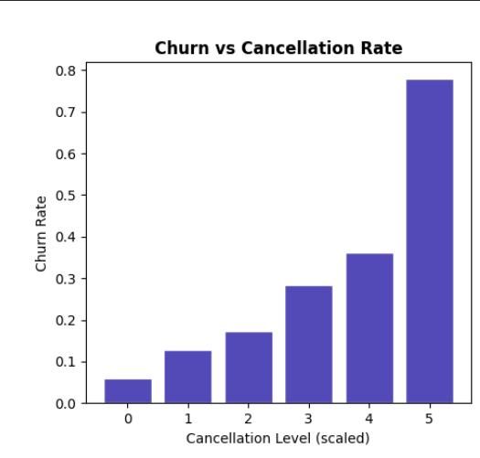

Customer Tenure

There was a significant difference in customer tenure between churned and retained customers. The median length of tenure for churned users was approximately 90 days and for retained users, it was more than 400 days. This indicates that the risk of churn is greatest at the beginning of the customer lifecycle. The results confirmed that long-term users had much higher levels of loyalty towards the platform, supporting the switching cost theory.
Users who spend more time on a platform become familiar with playlists, recommendations, and the interface, making them less likely to cancel their subscription.
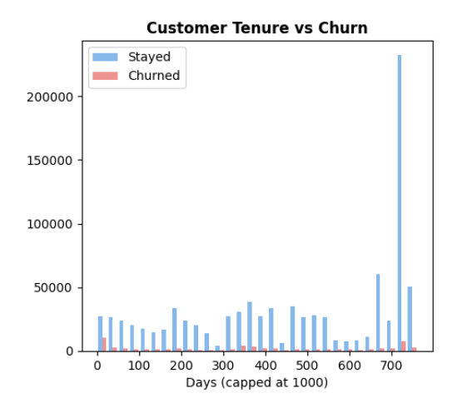

Plan Duration Effects

The churn rates were higher for the users who had shorter subscription period (30 days or less) than any user with longer subscription period. The lowest churn rates for the data collected were among those customers who signed up for an annual subscription.
This could be due to longer subscription periods are more desirable for more dedicated users and due to the monetary incentives for staying subscribed to an annual subscription. There was no linear direct relationship between plan duration and churn. Tree based models were better at capturing some of the more complex plans in some medium length plans than Logistic Regression.
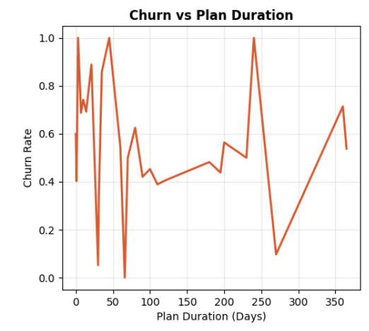

Feature Correlation Structure

The correlation analysis revealed that (auto_renew_rate) had the highest negative correlation (≈ −0.45) with churn. The cancel_rate was next, at around +0.30, and then the (tenure_days) at around −0.20.
The values of the correlation for all feature pairs were below 0.70, indicating that multicollinearity was not a significant issue for the linear models. Overall, the features captured various customer behaviour signals. Demographic factors like age, city, and gender had low association with churn. This was in line with the later SHAP analysis findings, indicating that behavioural features had a larger impact than demographic features.
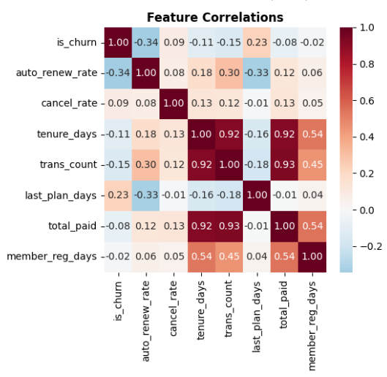
Summary of EDA findings & business implications
There were three important findings from the EDA which had a significant impact on the modelling process and business recommendations. First up, (auto_renew_rate) was the greatest predictor of churn. This was an important group to target for retention campaigns, as those that had disabled autorenewal had significantly higher churn risk. KKBox can help boost retention by offering recurring promotions, offers, or a more streamlined re enrolment process, such as automatically renewing after 90 days.
Secondly, the churn rate was significantly higher in the first 90 days of subscription. The company should shift its efforts to enhancing their customer engagement in the initial stages rather than concentrating on loyalty initiatives for long-term customers.
Third, there was a significant class imbalance issue due to the 6.4% churn rate. You can have a model which says that all users would not churn and have a very high accuracy, but it would have no business value. As a result, the project employed some metrics that better capture the capacity of the model to accurately determine users that are at risk of churn, such as ROC-AUC and PR-AUC.

IMPLEMENTATION OF ALGORITHMS AND MODELS

Modelling Philosophy and Experimental Design
Five machine learning models were trained and evaluated with increasing levels of complexity. This approach helped measure how much performance improvement was gained from each more advanced modelling method. It also prevented unnecessary use of very complex models when simpler models could provide similar performance with better interpretability.
All models were trained using the same 17 features, evaluated on the same validation dataset, and finally tested on the same unseen test dataset. This ensured fair comparison between all models and prevented any information from the test set from affecting modelling decisions.

Model 1: Dummy Classifier (Stratified Baseline)
The dummy classifier predicts churn by randomly following the class distribution in the training dataset without using any features. It acts as the minimum performance baseline. Any useful model should clearly outperform this baseline.
The model used the strategy='stratified' setting, which generates predictions using the same class proportions as the training data. The model achieved ROC-AUC= 0.4981 and PR-AUC = 0.0637.
These results are almost equal to random prediction and close to the base churn rate of 6.4%. This model established the minimum benchmark for later models.

Model 2: Logistic Regression
Logistic Regression was implemented using a scikit-learn Pipeline with a StandardScaler preprocessing step. Feature scaling was necessary because Logistic Regression uses L2 regularisation. Without scaling, features with large numeric values, such as (total_paid), could dominate features with smaller values such as binary variables.
The model used C = 0.1 for regularisation, class_weight ='balanced' to handle class imbalance.
The model achieved ROC-AUC: 0.8036, PR-AUC: 0.3401, Log Loss: 0.5026.
These results showed that the engineered features contained strong linear predictive information. However, the model could not fully capture complex non-linear relationships between features. Permutation importance analysis showed that (auto_renew_rate) was the most important feature with an importance score of 0.0459. (recency_days) ranked second with 0.0188, while (cancel_rate) ranked fifth with 0.0035.
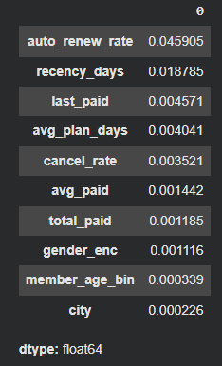

Model 3: Random Forest

The Random Forest model used 300 trees, maximum depth of 12, minimum leaf size of 50. The depth and leaf size limits helped reduce overfitting by preventing the trees from memorising the training data.
The (balanced_subsample) class weighting method was used to adjust class importance within each bootstrap sample.
The model achieved ROC-AUC: 0.8751, PR-AUC: 0.4595. This was a major improvement over Logistic Regression, showing the advantage of non linear modelling.
The training ROC-AUC was 0.8857 compared to validation ROC-AUC of 0.8751, creating a small overfitting gap of only 0.0106. This indicated that the model generalised well to unseen data.
The strong improvement over Logistic Regression showed that Random Forest could better capture feature interactions and complex behavioural patterns.

Model 4: XGBoost

XGBoost was configured with 1,000 estimators, learning rate of 0.05, maximum depth of 6, row and feature subsampling ratios of 0.8, min_child_weight = 5, scale_pos_weight = 14.4
The hist tree method was used to improve computational efficiency on the large dataset. XGBoost builds trees sequentially, where each new tree corrects the errors made by previous trees. This allows the model to learn complex non linear relationships more effectively than Random Forest.
The model achieved ROC-AUC: 0.8791, PR-AUC: 0.4824.
These were the highest ranking scores among all models until now.

Model 5: LightGBM with Optuna Hyperparameter Optimisation

LightGBM was selected for automated hyperparameter tuning because it trains efficiently on large datasets. LightGBM uses leaf wise tree growth, which expands the leaf that gives the highest information gain instead of growing all branches equally. This can improve performance but also increases overfitting risk if not properly regularised. The Optuna framework performed 30 hyperparameter search trials across multiple settings, including number of estimators, learning rate, tree depth, number of leaves, minimum child samples, subsampling ratios, L1 and L2 regularisation. Optuna used the Tree structured Parzen Estimator (TPE) method to focus future trials on high-performing parameter regions. Early stopping with 50 rounds of patience was used during training to reduce unnecessary computation.
The final tuned LightGBM model achieved ROC-AUC = 0.8768,Log Loss = 0.2151
Although its ROC-AUC was slightly lower than XGBoost, its Log Loss was much better than XGBoost’s 0.4021. This showed that LightGBM produced more reliable probability estimates.

SHAP Analysis
After training the models, SHAP (SHapley Additive exPlanations) analysis was applied to the final LightGBM model using 1,000 users from the test dataset.
The SHAP TreeExplainer method was used to calculate Shapley values efficiently for the tree-based model. SHAP values show how much each feature contributes to an individual prediction.
The SHAP summary plot ranks features based on their average impact on model predictions and shows whether feature values increase or decrease churn risk.
This analysis helped connect machine learning predictions with practical business insights. It allowed at-risk users to be grouped based on the reasons behind their churn risk instead of only using overall churn probability scores.
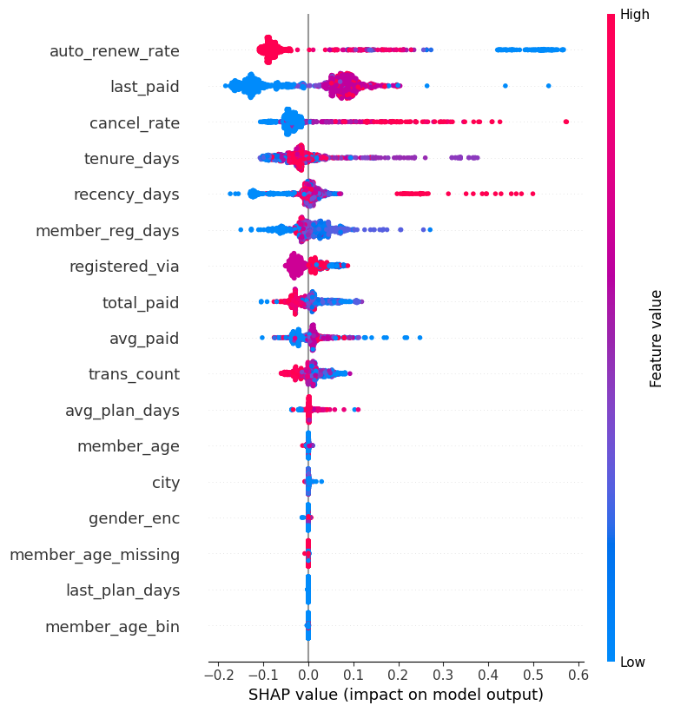

RESULTS AND ANALYSIS

Model comparison: Validation set
The performance of all the five models is presented in Table below based on ROC-AUC, Log Loss and PR-AUC on the validation dataset.
In the results it can be seen that the ROC-AUC gradually increases with complexity of the model as we move from the Dummy Classifier to Logistic Regression, Random Forest and Gradient boosting. The greatest improvement was seen between Logistic Regression and Random Forest with an increase in ROC-AUC from 0.8036 to 0.8751. This significant rise indicates that there are significant interactions between features in the data that are non-linear and are not adequately addressed by the linear model. The gains in the gradient boosting models were less with a gain of approximately 0.004 points over Random Forest. This is a very common pattern in tabular structured data where the more complex the model the less performance improvement you get.

Model | ROC-AUC, PR-AUC | Log Loss
4. XGBoost | 0.8779, 0.4852 | 0.3891
5. LightGBM (Optuna) | 0.8755, 0.4471 | 0.2158
3. Random Forest | 0.8751, 0.4595 | 0.4131
2. Logistic Regression | 0.8036, 0.3401 | 0.5026
1. Dummy | 0.4981, 0.0637 | 4.2990
Model Comparison Table

The Log Loss Advantage of LightGBM and Its Business Significance
The most important finding in the model comparison was the Log Loss result. LightGBM achieved a Log Loss of 0.2151, which was much lower than every model trained.
Log Loss is a measure of how accurate and confident the predicted probabilities are. This is an extremely significant finding for business decision making. Customer retention programmes typically have limited budgets and companies must determine who they wish to give customer retention offers or marketing assistance. If a company has USD 50,000 in its monthly retention budget, for instance, it's essential that it allocates more to the users who have the greatest risk of churn. The smaller Log Loss in LightGBM makes their predictions of the probability more consistent for these purposes. For a user predicted to be in 40% churn risk group by LightGBM, the actual churn probability is estimated to be around 40%. The less reliable nature of XGBoost's probability estimates is due to its many times higher Log Loss. This can result in under or overspending of low users or not getting the high users. Due to this, despite having slightly better ROC-AUC score on XGBoost, LightGBM was chosen as the production model.

ROC Curve Analysis
A test set was used to analyse the ROC curve of all four models except dummy classifier. Since each model was doing much better than random guessing, except the Dummy Classifier. The gradient boosting models had very close ROC curves and did a bit better than Random Forest particularly in the low false positive rate region. This is relevant to retaining customers as companies typically have limited budgets and do not want to spend money on sending out retention offers to users that aren't likely to churn.
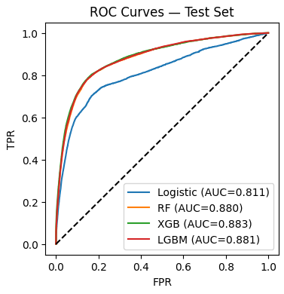

Overfitting Assessment
The training and validation ROC-AUC scores of the most complicated models were checked for overfitting. Random Forest model had Training ROC-AUC = 0.8857 Validation ROC-AUC = 0.8751 Difference: 0.0106 LightGBM also had a similar gap between train and validation accuracy. The two gaps were found to be below the common value of 0.02. This showed that the regularisation methods used in the models successfully prevented the models from memorising the training data.

Confusion Matrix and Threshold Optimisation
The final LightGBM model used an F1 optimised classification threshold instead of the default threshold of 0.5. This change was required due to the highly imbalanced nature of the data set and different costs of prediction errors. Churned users are not captured, and they miss out on retention assistance due to false negatives. The false positives occur when non churn customers are sent retention offers. The optimised threshold enabled the model to correctly detect a significant number of churned users while keeping the false positives in check. The classification report had precision and recall for both churned and non churned classes, which enabled to assess the nature of the prediction errors generated by the model.
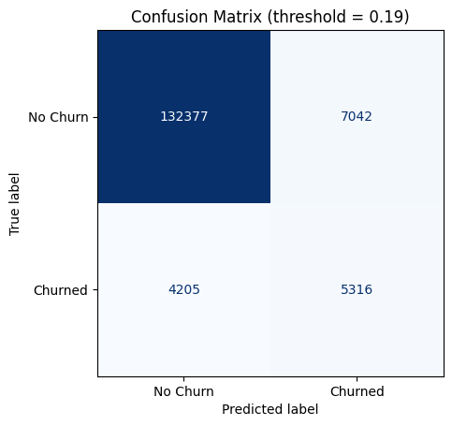

SHAP Feature Importance Results
Demographic variables like age, city and gender also had a significant contribution to the model, but the impact was not as good as the transaction based behavioural variables. This indicates that customer behaviour and user engagement on the platform are the primary drivers behind churn in KKBox, not customer demographics.
The SHAP results also showed the expected feature relationships. Churn probability was higher when the (auto_renew_rate) was higher. Higher cancel_rate caused a higher churn rate. The churn probability was increased by low (tenure_days). The (recency_days) feature was the second most important feature in the model. For those who had not made a transaction in recent times, before the cutoff date, churn risk was much higher, aligning with customary customer disengagement behaviour, before cancellation.

Explainability and Business Interpretability
The main problem for putting machine learning systems into use in commercial applications is the balance between interpretability and predictive performance. These simpler models are very easy to interpret, as the coefficient weights for each feature can be directly seen, and Logistic Regression is such a model. However, advanced techniques like XGBoost and LightGBM are more complex systems of decision trees, making it more challenging to understand the decision making process at the tree level.
This creates practical business challenges that make Customer retention teams accept a churn score model that doesn't offer some understanding of why some customers are deemed high risk. Additionally, there is a growing trend of regimes mandating that organisations make understandable explanations for automated decision systems, particularly when used to affect the treatment of customers or price formation.
The final LightGBM model was used to tackle this challenge by applying SHAP (SHapley Additive exPlanations) analysis. SHAP is based on cooperative game theory and is a measure of the contribution of each feature to a single prediction. SHAP values give feature effects and the direction of the effects, unlike traditional feature importance measures. By using SHAP analysis, it also makes the model more useful for the operations team as it enables them to create the interventions that are appropriate to the actual behavioural drivers of churn.
Furthermore, a key finding in this study was confirmed by the SHAP analysis is that the behavioural variables were more predictive than the demographic variables. Demographic categories, including age, sex and city, were always less important than features like (auto_renew_rate), (cancel_rate) and (recency_days). This discovery could have significant implications for digital subscription businesses. Customer behaviour is associated with the decisions of engagement and the satisfaction arising from the service, whereas the demographic variables are used as a description of static characteristics of users. Therefore, behavioural signals are more useful for identifying risk of churning.

BUSINESS INSIGHTS AND RECOMMENDATIONS

The Business Problem Restated
KK Box is subscription based business, they generate revenue through subscriptions through months and years. So, when someone cancels the subscription they not only loose revenue for that month but also the money coming from that customer down the line.
The data we have has 992,929 customers out of them only 6.43 percent (63,905 in number) only churned. The average subscription price is around 5$ per month and a typical customer stick around for 18 months. That means every time someone churns, KKBox loses an expected $90 in lifetime value.
If that 90$ multiplied by 63,905 churned users, then it is close to 5.25 million USD in revenue at risk. Now, if KKBox manages to keep even 15% of those users with a retention campaign, that’s $860,000 recovered right there. Numbers like these make it clear that predicting who might churn and acting on it isn’t just smart, it’s valuable.
According to Reichheld and Sasser (1990) it costs way more to get a new customer than to keep one. In music streaming, you might spend $10–$20 just to snag a new subscriber through ads or promos. Compare that with $2–$5 to keep someone you already have, and retention becomes more cost effective.

Model Output to Business Decision
The final LightGBM model gives every user a churn probability score between 0 and 1. The reason for picking this model above all is because of it’s low log loss score 0.241. Based on this churn probability score the users are categorized into three categories
1.People with churn probability score > (0.60) or 60% then these users are high are at risk to churn.
2.(0.30) < = People with churn probability score <= (0.60) then these users are at medium risk to churn.
3.People with churn probability score < (0.30) then these users are at low risk to churn
Based on these KK Box can spend wisely by spending more on High risk churners and by spending less on low risk churners.
Because LightGBM produces more reliable probability scores, it supports better financial decision making and more efficient use of retention resources.

Insights
1.From this project it is evident that (auto_renew_rate) was the best churn predictor. It is proved from both EDA and model prediction. So, the users who are more likely to turn off the auto renewal feature are more likely to churn. Users with low auto renewal rates churned at about eight times the rate of users who kept auto renewal enabled.
2.Users with high cancelation days were most likely to churn later. Users who repeatedly cancel subscriptions but later renew again are already showing warning signs long before final churn occurs. The high risk users are those with high (cancel_rate) and high (regency_days).
3. One of the important findings was that churned users had a median tenure of only about 90 days, while retained users stayed for more than 400 days on average. This means churn risk is highest during the first few months after joining the platform. Instead of focusing mainly on long term loyalty programmes, KKBox should invest more in improving engagement during the first 90 days of a customer’s subscription.
4. While the churn prediction system offers significant business value, there are still key risks to consider.
While the churn prediction system offers significant business value, there are still key risks to consider.

False Positive Risk
There are certain users that may be misclassified as high risk users when they'd never churn. If such users are targeted with discounts or heavy marketing, the firm might end up wasting its retention investment. This risk is lower thanks to the excellent probability calibration of LightGBM that makes its predictions more reliable.

Model Drift Risk
Information for the model was based on 2016-2017 data, and customer behaviour might change over time. To minimise this risk, model should be retrained on a regular basis, Distributions must be monitored continually on new data.
Intervention Fatigue Risk
A too high number of retention messages or offers that are irrelevant can upset users and be a negative customer experience. To avoid this, Daily communication frequency needs to be kept to a minimum, Conducting and A/B testing can be used to determine the most successful approach to retention for various customer segments.

Recommendations
1.First recommendation is to target users who turned off their auto renewal feature off recently. The company can send personalised offers such as music recommendations, special discounts, or easy one click rebew subscription options. Users with high churn risk and low auto renewal activity should receive priority support and retention offers first.
2.Creatating a weekly churn monitoring system using the LightGBM model and working on users with churn probability above 50%. They should receive retention messages and personalised recommendations. If users still show high churn risk after two weeks, then the customer support teams should review these accounts and provide stronger retention offers.
3.By Introducing a 90 day onboarding programme for new subscribers and during the first month, users should learn platform features such as playlists and offline listening. In the second month, the app should provide personalised music recommendations. In the final month, users should receive discounts or offers encouraging them to enable auto renewal. The LightGBM model can help identify high risk new users early for additional support.

ETHICAL CONSIDERATIONS AND DATA PRIVACY
Ethical concerns are still crucial for churn prediction systems, even though the data in this project is anonymous public data. Customer behaviour based machine learning models can influence the way that companies allocate marketing offers, discounts and customer support. A poorly designed system can have a negative effect on certain user groups.
KK Box removed the user personal information and created user hash IDs before releasing the dataset to public. This helped to safeguard consumer privacy and minimize the possibility of consumer identification. But there can be patterns in the behaviour of transactions that are sensitive, so there is a need for responsible handling of the data.
Certain characteristics such as age, gender and city should be included in the churn prediction but over relying on such data can result in unfair decisions. The risk of bias was minimized in this project as behavioural attributes outweighed demographic attributes.
Customer behaviour evolves over time due to market competition, pricing, and user behaviour. This can lead to model drift, in which older models are less accurate. To reduce this risk, it is essential to regularly monitor and retrain the model using new data.

CONCLUSION

Summary of Key Findings
This project involved creating and testing a machine learning pipeline to predict churn for the KKBox WSDM 2018 dataset, which consists of 992,929 labeled users, 21.5 million transactions, and subscriber demographic data. The main methodological asset is the explicit identification and correction of temporal data leakage, a systematic error that, if not corrected, led to AUC values above 0.97, but that was corrected using a strict transaction cutoff on 31 January 2017, and resulted in realistic and defensible AUC values ranging from 0.877 to 0.879 ROC-AUC. Five models were trained and tested systematically, and a hierarchy of performance could be established. The logistic regression had an ROC-AUC of 0.8036, which set the logistic regression linear predictive ceiling. Random Forest brought this up to 0.8751, which was the power of the non-linear modelling. XGBoost had the best performance in the ranking with the values of 0.8791 ROC-AUC and 0.4824 PR-AUC. LightGBM with hyperparameters optimized by Optuna performed better in probability calibration, with Log Loss of 0.2151 and ROC-AUC score of 0.8768, which is 47 percent better than XGBoost, and is the best model for operational deployment. The subscriber behaviour was found to be a much more powerful driver of churn predictions than the demographics are auto renewal rate, recency, and cancellation rate were the top three features in terms of feature importance in the SHAP analysis.

Limitations
There are some limitations also to note. While technically required to prevent leakage, the time period cut off diminishes the amount of transactional information that can be used for feature engineering and removes behavioural signals from the last few weeks of the prediction window that would be accessible in a prospectively deployed system. When using training set medians to impute missing transaction features, there may be some bias for the subset of users that do not have transaction features up until their cutoff date, for which all transaction features are imputed instead of observed. The Optuna hyperparameter search is not as arbitrary as manually tuning but covers only a fraction of the search space in 30 trials, and more trials could lead to more gains in performance. Lastly, the dataset is based on the behaviour of subscribers during 2016-2017 in selected Asian markets, but the feature importance results may not be generalisable to a current streaming environment or other geographical regions without validation on more recent data.

Future directions for research
Further studies of this type might proceed in a number of directions. The use of user listening behaviour data (stream count, skip rate, creation of playlists, frequency of listening to playlists) would add a lot of additional features and possibly reveal indicators of engagement not captured by transaction data. Modelling techniques like recurrent neural networks or temporal convolutional networks can capture the sequential aspects of subscriber engagement that are not possible with aggregation.
Survival analysis models would also help to better estimate when an at risk subscriber is likely to churn instead of just predicting whether they will remain or not, which would help to better time retention actions. Finally, a deployment ready deployment pipeline was built to apply the LightGBM model on the real time transactions data would take this analytical project to the next level, connecting the dots between this work and real operational retention management and push the value towards sustained business value.
Another step in the development of this work would be to make the analytical pipeline fully automatic and production ready machine learning system. In the real "commercial" environment, churn prediction models are not typically run on their own as notebooks. Rather, they work in a continuous Machine Learning Operations (MLops) pipeline, where new transactional data is automatically fed into the system, new features are automatically created, models are automatically retrained regularly, and new predictions are automatically pushed to operational dashboards.
Model drift detection systems would also have to be automated for a production deployment. The statistical characteristics of customer behaviour can change over time as a result of price changes, listening habits in certain seasons, or economic factors. It would be helpful if distributions of important variables like (auto_renew_rate) and (recency_days) were monitored to understand when a retraining is needed.
Scalable deployment of the prediction pipeline could also be achieved via containerisation technologies like Docker and orchestration platforms like Kubernetes. The model could run in a cloud based setup, efficiently processing millions of transactions without compromising on prediction latency.

References
Akiba, T., Sano, S., Yanase, T., Ohta, T. and Koyama, M. (2019) ‘Optuna: A next-generation hyperparameter optimization framework’, Proceedings of the 25th ACM SIGKDD International Conference on Knowledge Discovery and Data Mining, pp. 2623–2631.
Au, W.H., Chan, K.C., Wong, A.K. and Wang, Y. (2003) ‘A framework for churn prediction in customer relationship management’, Information and Management, 40(7), pp. 569–581.
Bergstra, J. and Bengio, Y. (2012) ‘Random search for hyper-parameter optimization’, Journal of Machine Learning Research, 13(1), pp. 281–305.
Breiman, L. (2001) ‘Random forests’, Machine Learning, 45(1), pp. 5–32.
Chawla, N.V., Bowyer, K.W., Hall, L.O. and Kegelmeyer, W.P. (2002) ‘SMOTE: Synthetic minority over-sampling technique’, Journal of Artificial Intelligence Research, 16, pp. 321–357.
Chen, T. and Guestrin, C. (2016) ‘XGBoost: A scalable tree boosting system’, Proceedings of the 22nd ACM SIGKDD International Conference on Knowledge Discovery and Data Mining, pp. 785–794.
Davis, J. and Goadrich, M. (2006) ‘The relationship between Precision-Recall and ROC curves’, Proceedings of the 23rd International Conference on Machine Learning, pp. 233–240.
Hadden, J., Tiwari, A., Roy, R. and Ruta, D. (2007) ‘Computer assisted customer churn management: State-of-the-art and future trends’, Computers and Operations Research, 34(10), pp. 2902–2917.
He, H. and Garcia, E.A. (2009) ‘Learning from imbalanced data’, IEEE Transactions on Knowledge and Data Engineering, 21(9), pp. 1263–1284.
Idris, A., Rizwan, M. and Khan, A. (2012) ‘Churn prediction in telecom using Random Forest and PSO based data balancing in combination with various feature selection strategies’, Computers and Electrical Engineering, 38(6), pp. 1808–1819.
IFPI (2023) Global Music Report 2023. London: International Federation of the Phonographic Industry.
Kaufman, S., Rosset, S., Perlich, C. and Stitelman, O. (2012) ‘Leakage in data mining: Formulation, detection, and avoidance’, ACM Transactions on Knowledge Discovery from Data, 6(4), pp. 1–21.
Ke, G., Meng, Q., Finley, T., Wang, T., Chen, W., Ma, W., Ye, Q. and Liu, T.Y. (2017) ‘LightGBM: A highly efficient gradient boosting decision tree’, Advances in Neural Information Processing Systems, 30, pp. 3146–3154.
Lundberg, S.M. and Lee, S.I. (2017) ‘A unified approach to interpreting model predictions’, Advances in Neural Information Processing Systems, 30, pp. 4765–4774.
Martínez, A., Schmuck, C., Pereverzyev, S., Pirker, C. and Haltmeier, M. (2020) ‘A machine learning framework for customer purchase prediction in the non-contractual setting’, European Journal of Operational Research, 281(3), pp. 588–596.
Reichheld, F.F. and Sasser, W.E. (1990) ‘Zero defections: Quality comes to services’, Harvard Business Review, 68(5), pp. 105–111.
Saar-Tsechansky, M. and Provost, F. (2007) ‘Handling missing values when applying classification models’, Journal of Machine Learning Research, 8, pp. 1623–1657.
Wlömert, N. and Papies, D. (2016) ‘On-demand streaming services and music industry revenues — Insights from Spotify’s market entry’, International Journal of Research in Marketing, 33(2), pp. 314–327.

Appendices

1.GitHub Repo link: https://github.com/OPAMIDI/KKBoxChurnPrediction

AI Disclosure

For the code (Level 4):
Claude (Anthropic, claude.ai) was used extensively throughout
the coding process. Key contributions included feature engineering
pipeline design, temporal leakage identification and fix, model
training code for all five models, Optuna hyperparameter search
implementation, SHAP analysis, and debugging of runtime errors.
All AI-generated code was critically evaluated, tested, and
integrated by the student.

For the written report (Level 2):
Claude (Anthropic, claude.ai) was used to brainstorm section
themes and suggest report structure. All written content in the
final submission was independently authored by the student.
No AI-generated text appears in the report.
